5
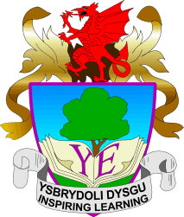

YSGOL EIRIAS

RESPONSIBILITY | STAFF MEMBER | GOVERNOR
Primary liaison | David Bowen-Jones  Head of Year 7 | VACANT
Responsible Officer | Gwyn Jones  Business Manager | Howard Ferdinando
Health and Safety | Drew McKenzie D/HT | Dilwyn Jones
e-safety | Craig Faulkner | Jayne Humphreys
Equal Opportunities  Student Link | Drew McKenzie D/HT  Abigail Beards | Kerry Jones
Food and Nutrition | Elie Owen | Julie Hind
Additional Learning Needs (ALN) | Louise Kerfoot-Robson A/HT | Kathryn Williams
Careers | Jo Rowlands | Rob Darnell
Child Protection – Wellbeing  Looked After Children (LAC) | Drew McKenzie D/HT  Louise Kerfoot-Robson A/HT | Chris Warner
LIST OF GOVERNORS WITH A DESIGNATED RESPONSIBILITY - 2021/22

Issue 1 – Sept 2021

