|  |  |
| --- | --- |
| Ysgol Eirias**Governors’ annual report 2019** | bilibgual crest |

+

This annual report of the governors relates to the 2018/19 school year

|  |  |  |  |  |  |  |
| --- | --- | --- | --- | --- | --- | --- |
| 1 | Throughout the year the governors of the school (together with their status and end of term of office) were: | | | | | |
|  | Parent Governors | **(x7)** | | LA Appointed | **(x2)** | |
|  | Mrs J Hind | 07/22 | | Cllr A Khan | 09/20 | |
|  | Mr D Jones | 01/23 | | Cllr D Milne | 09/20 | |
|  | Mrs W Kitson | 02/20 | |  |  | |
|  | Mr H Mirza | 07/21 | |  |  | |
|  | Mrs N Richardson | 11/22 | |  |  | |
|  | Mr R Dickson | 07/19 | | Staff Governors | **(x3)** | |
|  | Mrs C Rudgley | 05/22 | | Mrs R Haslock (teaching) | 10/21 | |
|  | Mrs K Williams | 07/19 | | Mr M Mercer (non-teaching)  Mr N Wilkinson (teaching) | 09/20  09/20 | |
|  |  |  | |  |  | |
|  |  |  | |  |  | |
|  | Community Governors | **(x3)** | | Partnership Governors | **(x5)** | |
|  | Mr R Darnell | 11/19 | | VACANCY |  | |
|  | Mr C Warner | 09/23 | | Mr H A Ferdinando | 02/21 | |
|  | Mr A Keep | 11/20 | | Mr G Hughes | 09/23 | |
|  |  |  | | Mr J K G Jones | 09/23 | |
|  | **Head-teacher (ex-officio)** | |  | Mrs J Humphreys | 11/23 | |
|  | Mrs S Sutton  **Associate student Governors (x2)** | |  | Mrs A Monks-Roberts | 09/23 | |
|  | Leah Scott 09/19  Gage Wilson-Noon 09/19 | | | | | |
| 2    3 | The **Chair of Governors,** up to 31st August 2019, was Mr J K G Jones who may be contacted through the school. The **Vice-Chair and Responsible officer** was Mr H A Ferdinando.  **Governors with special responsibilities** include:  Mr C Warner – Child Protection -Wellbeing/Looked after children (LAC);  Mr K Jones – Equal Opportunities; Student link  Mrs Kathryn Williams - Additional Leaning Needs (ALN)  Mrs J Humphreys - e-safety  Mrs J Hind – Food and Nutrition  Mrs W Kitson – Primary liaison  Mr D Jones – Health and safety  The **Clerk to the Governors** (Mrs Sarah Noke) may be contacted at the school.  (Ysgol Eirias, Eirias Road, Colwyn Bay, CONWY LL29 7SP  Tel – 01492 532025 e-mail: [general@eirias.conwy.sch.uk](mailto:general@eirias.conwy.sch.uk) ).  There was no meeting requested by parents (In accordance with the requirements of the Schools Standards and Organisation (Wales) Act 2013) and subsequently there were no **resolutions** raised / passed as a result of the publication of last years’ Governors Annual report. | | | | | |  |  |  |
| 4  5  6 | The date of the next scheduled vacancy for a Parent governor is February 2020. Around that date applications from those eligible will be invited via the school web-site. If there are more applications than there are vacancies a ballot will be organized.  The number of students in school remains stable at approximately 1350.  In September 2019 there were approximately 90 full-time equivalent teachers and 50 full-time equivalent support staff.  The projected recruitment into the 6th form in September 2019 was again in line with previous years.  The schools **results** in the summer 2019 public examinations were excellent and in most subjects continued the overall trend of improvement noted over recent years. The school had excellent ‘A’ level, GCSE and vocational qualification results. Details of these **examination results** and of **the assessment results for key stage 3** are given in ***Appendix 1***. In summary, GCSE results were as predicted; ‘A’ level pass rate was over 99% and over 65% were at the top A*-B grades.  94% of the sixth form students took up the offers they were holding from a wide range of universities. | | | | | |
| 7 | The school works successfully to a comprehensive **Additional Needs policy** *(Policy No. 43),* which aims to support under-achievers both through individual tuition and small classes in the schools’ Special Needs Department, EPIC Unit and by additional teacher help in other classes outside this department.  Similarly, enrichment work is arranged for those to whom the syllabus proves less challenging (**More able and talented Policy** *(Policy No. 9))*. Each class activity is designed to provide for the different needs of each student as far as is possible. | | | | | |
| 8 | Around 57% of Year 11 students stay-on to attend the 6th form. Charts showing the destination categories of school leavers at 16 and at 18 are shown in ***Appendix 1.*** | | | | | |
| 9 | The school uses a wide range of strategies in order to raise student achievement and to create an environment that is conducive for teaching and learning. These strategies are reviewed regularly to ensure they deliver maximum positive impact. A variety of grade improvement classes were held prior to the main examinations and professional learning coaches spent a day on revision techniques.  The school has a well embedded transition programme which focuses on both feeder and non-feeder primary schools alike. | | | | |
| 10 | Students have continued to excel in very many **sporting** and artistic activities, both in curriculum subjects and after school as extra-curricular interests and in local clubs/societies. Students have successfully participated in a wide range of sporting events at local, county, national and international levels. The high quality standard sports facilities available within the Eirias Park Sports Complex provide well for a wide range of physical sports activities – students make extensive use of these facilities. The school is an active participant with the national Healthy Schools Initiative and has successfully achieved the Active Mark.  Within the Iechyd Da project, our Year 7 students have been gaining knowledge and understanding around the importance of a healthy balanced diet.  Students have been learning about the different food groups, nutrition for exercise and the importance of calorie and sugar intake within both their theory and practical lessons.  A full range of cookery skills is being covered in KS3, with the promotion of cooking healthy family meals to suit nutritional needs.  The Technology and PSE schemes of work have been adapted to address the results of our SHRN report.  Promoting healthy breakfast choices and eating 5 fruit and veg a day are two examples of how this has been done.  The extensive and impressive range of visits and extra-curricular activities, together with opportunities for extra personal study, provided daily for one hour after school and freely available to all students continues to be very well supported. We continue to encourage those who do not attend to consider the benefits of this extra-curricular facility.  Students, during the last year, have participated in over 100 trips and these have included students travelling extensively, for example, to Greece, Germany, France, Borneo and Italy. | | | | | |
| 11 | Discipline is enforced where necessary and a very small number of students have been excluded from school for various periods where, in the opinion of the Head-teacher and Governors, their attendance and behaviour detracted from the education and well-being of other students and staff. We continue to require that all students always conform to school rules, attend school regularly and arrive punctually. As a result of appropriate staffing and consistent implementation of the schools’ behaviour related policies the number of exclusions remains consistently low.  The effective utilization of the electronic registration and automated alert procedures has continued to help reduce the level of unauthorized absences, improve the level of attendance and reduce the frequency of truancy. The average **attendance** rate in 2018/2019 was 93.6% marginally below target. Of the absences 4.1% were authorized and 2% unauthorized. We strongly discourage students being taken out of school for holidays during term time. Further attendance details are shown in ***Appendix I.*** The current attendance target (for 2019/20) is 94%. | | | | | |
| 12 | The schools’ delegated budget has been professionally managed and extremely well controlled.  The Governors continue to maintain financial prudence against future fluctuations in funding and have retained a positive balance, albeit very small – a significant proportion of which must be utilized to balance the new year budget because of the significant continual funding reductions. A **balance sheet** is given in ***Appendix 1.***  In accordance with current policy no travel and subsistence allowances have been paid to governors. | | | | | |
| 13 | The School’s **policy documents** have been reviewed and revised to take account of recent procedural and practical changes and to align with the school’s policy review timetable (apart from those that require review on an annual basis all other policies are reviewed on a 3 year rolling cycle). The policy documents are available at the School and via our web site, [***www.eirias.co.uk***](http://www.eirias.co.uk) ***.*** Details of the amendments made to the policy documents are recorded in the school’s ‘Policy document change register’.  The policies reviewed/amended throughout the year include:-   |  |  | | --- | --- | | **Policy number** | **Policy title** | | 3 (Issue 9) | Assessment | | 4 (Issue 8) | First aid | | 5 (Issue 11) | Whole school pay | | 6 (Issue 12) | Charging and remissions requirements | | 11 (Issue 12) | Lettings | | 14 (Issue 8) | Staff grievance | | 15 (Issue 21) | Admissions | | 16 (Issue 8) | Rewards | | 17 (Issue 8) | Sanctions | | 19 (Issue 13) | Safeguarding and Child Protection | | 20 (Issue 10) | Leave of absence (Previously known as Staff absence) | | 22 (Issue 9) | Staff disciplinary | | 33 (Issue 8) | Security | | 36 (Issue 8) | Careers Education | | 38 (Issue 13) | Terms of reference – Committees and Panels | | 41 (Issue 8) | School discipline | | 43 (Issue 11) | Additional Needs (ALN) | | 45 (Issue 14) | Performance management | | 47 (Issue 6) | Publications | | 48 (Issue 5) | CCTV | | 58 (Issue 4) | Cover | | 56 (Issue 9) | Educational visits | | 57 (Issue 4) | Welsh language | | 59 (Issue 4) | Award bearing courses | | 60 (Issue 5 + 6) | IT security | | 63 (Issue 4) | Critical incident emergency procedures | | 68 (Issue 3) | Literacy | | 66 (Issue 3) | Photos and images | | 75 (Issue 1) | (NEW) Dignity at work | | | | | | |
| 14 | The numerous **strategies**, **targets** and objectives contained in our regularly reviewed Self-evaluation and School Development Plan (SDP) are without exception, on course for completion by their scheduled dates. The SDP document, which is based upon the continuous self-evaluation processes (including analysis of the Core Data Set) is available at the School. In accordance with the Education (SDP) (Wales) Regulations 2014 a summary of the SDP is given by the agreed prime targets are contained in the four main ***’Whole School Targets’*** shown in ***Appendix 1.***  As has been the case for the last 10 years or so Whole School Target number 1 always relates specifically to student performance – ‘To enhance student performance ……..’. | | | | | |
| 15 | The Governors confidently advise that the School has had another very successful year – a result of effective teaching, sound management and good student attitude. We recognize the ability, commitment and enthusiasm of teachers and support staff, and the voluntary responsibilities taken by parents. | | | | | |
|  |  | | | | | |
| 16 | The school **prospectus** is readily available in several formats. Annually updated inserts include the most recent examination results, attendance/absence details and a range of other relevant information. The contents of the prospectus are designed to meet national requirements.  A separate prospectus/information book is available for the 6th Form (Years 12 and 13).  Specific details about the **curriculum** and the organization of education and teaching methods are contained in the prospectus. The curriculum subjects are organized into ten Faculties – Mathematics; Science; Technology; Humanities; English; Modern Foreign Languages; Welsh; Business and Communications, Welsh Baccaluareate and Physical Education.  Details of **term dates and session times** are available for current and future years on the School web site. The school day starts at 8:50 and ends at 3:00 with a 40 minute lunch break. Lesson periods are of 50 minutes duration.  **Term dates for the 2018/2019 year are**:-  Autumn term – 5th September to 21st December Half term 26h October –5th November  Spring term - 7th January to 12th April Half term 22nd February – 4th March  Summer term – 29th April to 19th July Half term 24th May – 3rd June  **Term dates for the 2019/2020 year are**:-  Autumn term – 4th September to 20th December Half term 25th October –4th November  Spring term - 7th January to 3rd April Half term 14th February – 24th February  Summer term – 20th April to 17th July Half term 22nd May – 1st June | | | | | |
| 17 | **Links with the community** are considered very important aspect of school life and through a variety of initiatives and liaisons these continue to be enhanced and strengthened. Many £1000s have been raised for local, national and international charitable causes. Links with other Conwy secondary schools and Llandrillo College have been reinforced through the extensive programme of collaboration. Links with several other North Wales secondary schools have been established in conjunction with our involvement as a lead practitioner school for MFL and Science. A significant number of staff work closely with other schools as part of several GWE and National initiatives. | | | | | |
| 18 | The School adheres closely to all its **equal opportunities** related policies and its **Strategic equality plan**. However, due to the school being located in five separate buildings and up to three floor levels full access for any person with disability is not always practical (The LA has made suitable provision for these in other schools in the county for those with mobility disabilities).  A copy of the schools’ **Accessibility Plan** is available at the school. Although the newer buildings within school are fully DDA (Disability Discrimination Act) compliant, the older buildings, spread over 2 or 3 levels are not. Appropriate arrangements are made for students (or parents) with a disability.  All students attending school are fully integrated in all aspects of school life.  The annual safeguarding report has been completed in accordance with Welsh Government requirements. | | | | | |
| 19  20  21 | There were two formal **complaints** received during the year. These were satisfactorily resolved at stage 1 of the school’s complaint procedures.  The designated **language category** of the school is English.  In accordance with current legislation Welsh is taught to all students up to Key Stage 4 (GCSE) level. At Key Stage 5 (AS and A levels) Welsh is a selective subject. Although the incidental use of Welsh throughout the school is actively encouraged no subject is taught through the medium of Welsh. Most students follow the full GCSE Welsh course. First language Welsh GCSE course was added to the school’s curriculum two years ago.  Adequate toilet facilities are available for both students and staff in each of the school teaching/learning blocks.  Cleanliness of these facilities is monitored frequently throughout each school day by the site management staff and are cleaned at least after the end of the school day by the school’s team of cleaners. | | | | | |
|  | scan J K G Jones ***Chair of Governors Date January 2020*** | | | | | |
|  |  | | | | | |
|  |  | | | | | |

*If you have any questions regarding any aspects of this report please complete the reply slip below and return it to The Clerk to the Governors (Mrs S Noke) at the school address.*



**Ysgol Eirias**

**Governors Annual Report – 2018/19 year**

|  |  |
| --- | --- |
| **Question**  **Number** | **Question detail** |
|  |  |
|  |
|  |
|  |  |
|  |
|  |
|  |  |
|  |
|  |

**Signed …………………………… Parent of ……………………………… Year group ……...**

**Date……………………………….**



*APPENDIX 1*

**Governors' Annual Report 2018/2019**

STATISTICAL INFORMATION

• Examination results details

• Key Stage 3 – Year 9 assessment levels• comparative data

• Key Stages 4 and 5 - SSSP

• Destination of school leavers

• Attendance and absence details

• Whole school targets

• Finance - Balance sheets



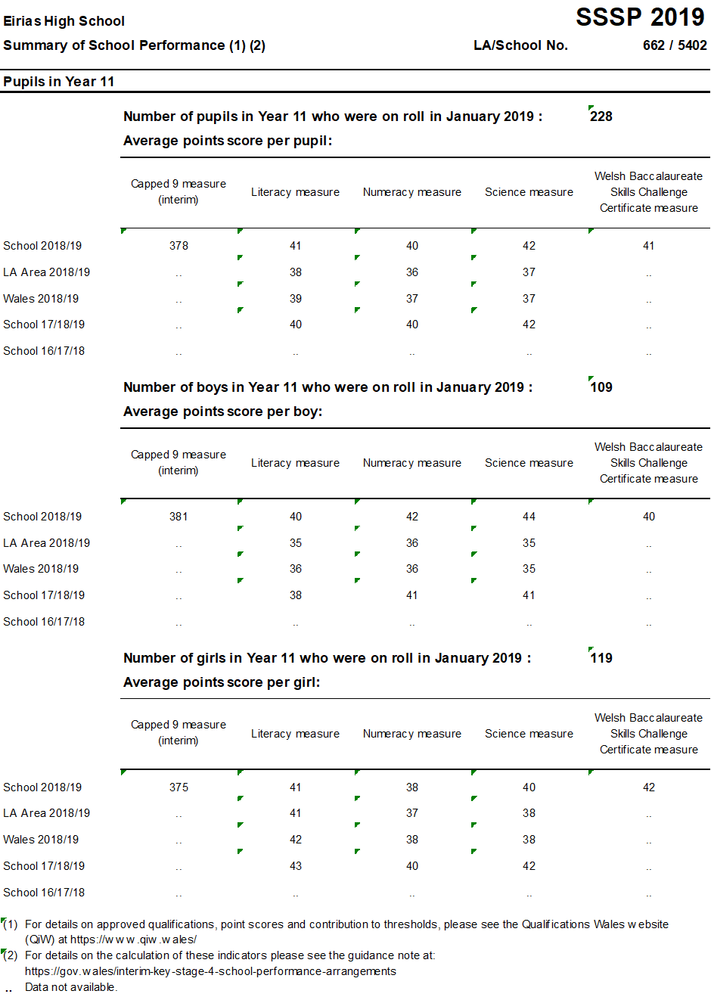

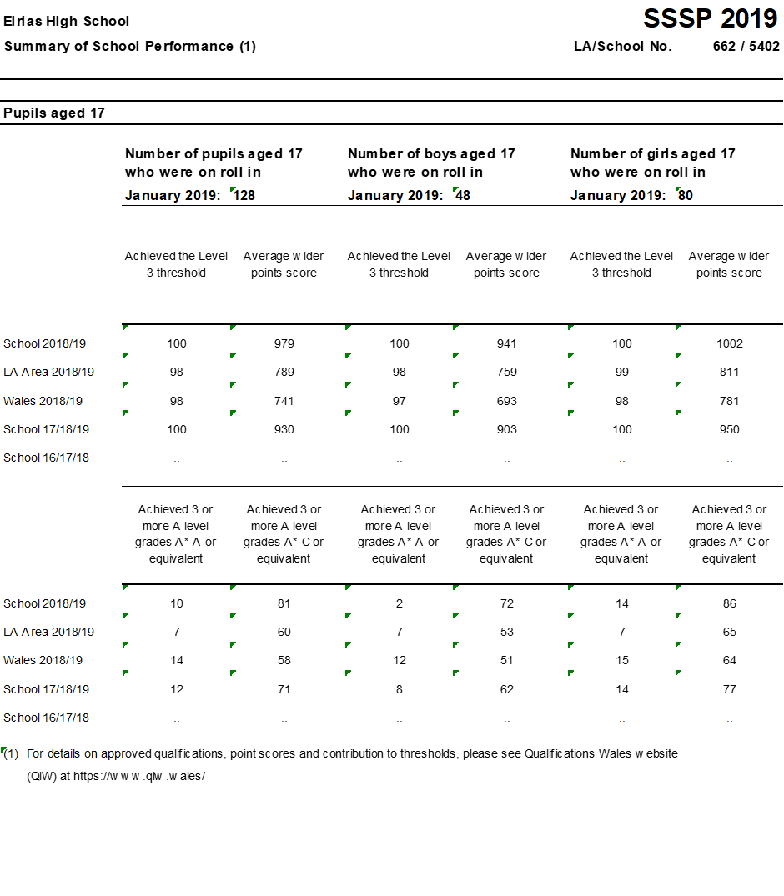

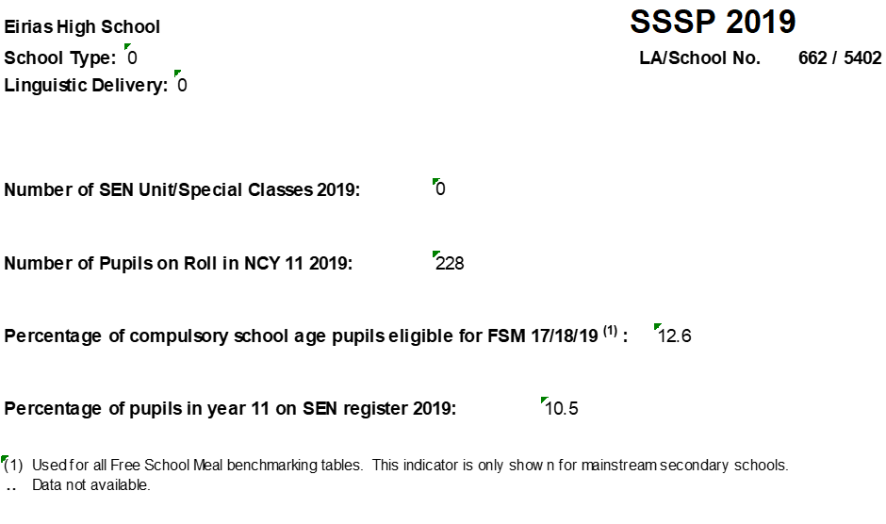

# Year 11 and Year 13 Leaver Destinations June 2019

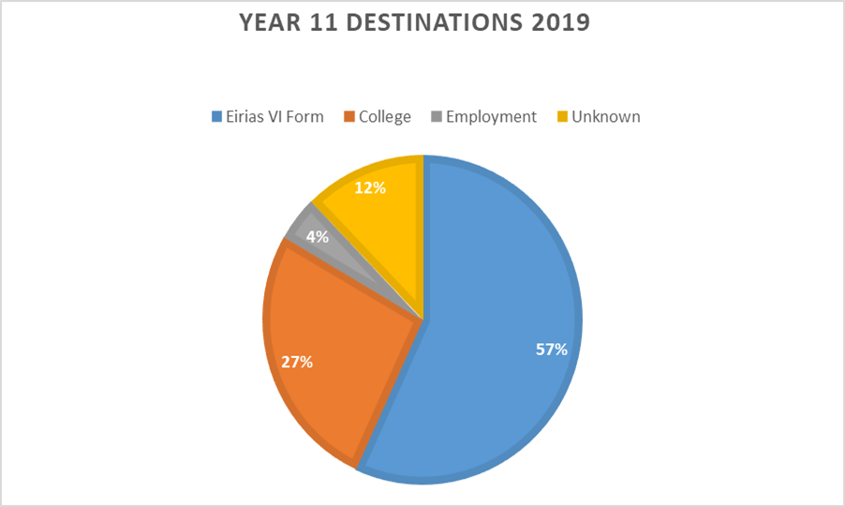

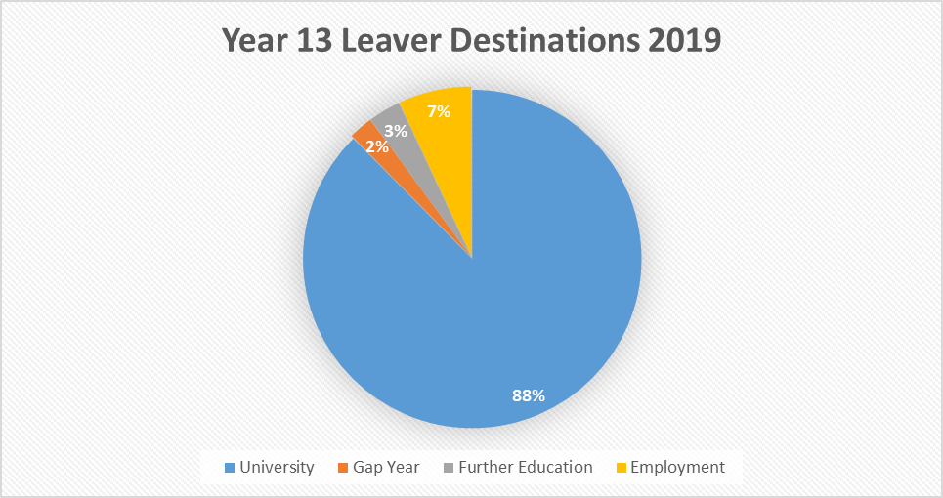

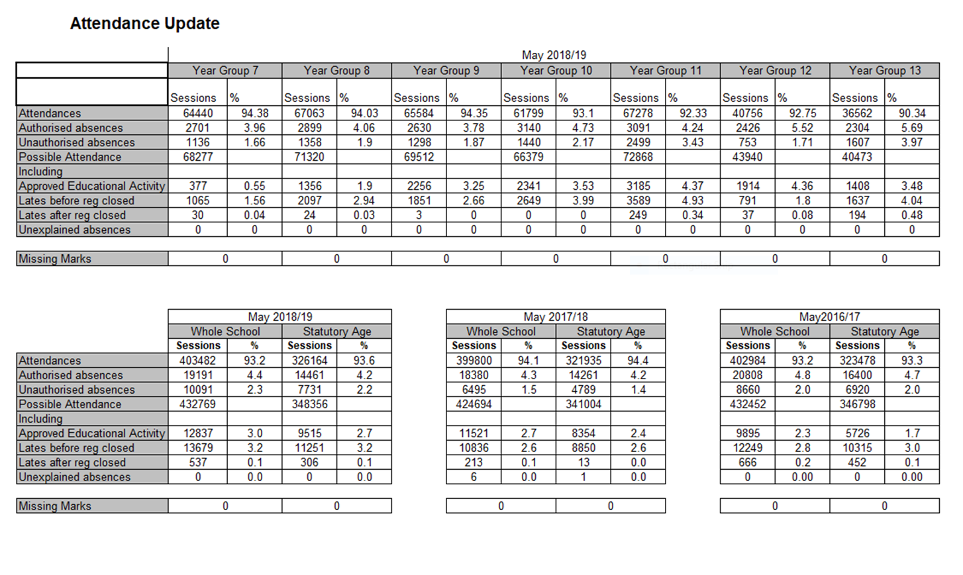

**Whole School Targets 2018/19**

|  |  |  |  |  |  |
| --- | --- | --- | --- | --- | --- |
| *Target* | *Staff* | *Current Evaluation* | *Evidence* | *Impact* | *Additional Budget Implications* |
| The school is committed to achieving the best possible standards of attainment and achievement for our learners regardless of background, gender or academic ability. | | | | | |
| *Enhancing Student Performance*   * To enhance student performance by achieving GwE value added target   *Highlights:*   * *Outcomes at KS3, KS4 and KS5* | **SSN** | **KS3 (2018):** English 94 % (91%), Mathematics 95% (92%), and Science 96% (95%)  (% Conwy 2017 comparison)  **KS4 (2018):** Current tracking data shows that we are making progress towards target.  **KS5 (2018):** Current tracking data shows that we are making good progress to achieve 60% at the A*-B threshold. | **KS3 (2018):** CSI average of 93%  **KS3 (2017**): CSI average of 88 %  **KS4 (2018):** Unverified 2018 KS4 data places the school L2+ at 56 %; in currently, moderate alignment with the 2018 target of 66%  Unverified 2018 KS4 data places the school at 56 % for the National WBQ.  Unverified 2018 KS4 data places the school 5A*A at 20%  **KS4 (2017):**  L2+ 61 % - on target  Gender gap: female/male - 11%, LA - 7 %, family 11%, Wales - 8%  FSM benchmarking places the school in the 3rd quartile for L2/L2+ threshold and the 4th quartile for L1 threshold.  L1 97%, LA 96%, Wales 94%, Family 97.2%  **KS5 (2017**): KS5 data places the school at L3 100%. A*-A 36%, A*-B 61%  **KS5 (2018):** Unverified 2018 KS5 data places the school at L3 100%. A*-A 42%, A*-B 67% | **KS3 (2019)**  CSI 90%  **KS4 (2019)**  Capped 9: 380  WBQ: 65%  L2+: 66%  L1: 99.5%  FSM L2+: 45%  A*A: 24%  **KS5 (2019)**  A*-B: % 65%  A*-A: % 38% | N/A |
| *Target* | ***Staff*** | ***Current Evaluation*** | ***Evidence*** | ***Impact*** | ***Additional budget implications*** |
| Ysgol Eirias is well informed regarding the New Curriculum and has made significant steps in preparation for changes. This includes significant involvement in ITE reform, in use of the New Standards, in addressing issues raised through the New Curriculum and pedagogies. We are developing new pedagogies in line with cognitive science and providing personalised professional learning programmes to enhance this provision. Schemes of work reflect the developments and are moving towards mastery through aspects such as spaced learning, retrieval practice, interleaving and effective homework. | | | | | |
| *Teaching*   * Deepening Pedagogy   *Highlights:*   * *Improved ITE work with CaBan and the HEI providers including preparation for Cymraeg Pob Dydd* * *A clear pathway of personalised training at all levels for all staff* * *Latest pedagogy confidently used in the classroom.* * *Language of Learning develops learner skills in conjunction with curriculum knowledge.* * *Effective questioning and subsequent feedback are essential areas of responsive teaching* | **HBL**  **ZES** | *CaBan proposal in early stages – accreditation awarded with stipulations in June 2018.*  *Cluster sessions in Welsh medium delivery.*  *Incidental Welsh programme in place at YE; impact is inconsistent.*  *Beginner and Intermediate Cymraeg was on offer on the Opt in Training Day and was well attended (17 opt ins)*  *The school has previously audited use of Curriculum Cymraeg.*  Career Development Pathway has been devised for all teaching staff and support staff. It has been utilised by interested staff this year and has generated leadership opportunities.  Governor training is limited. TA training opportunities are available but inconsistently applied.  Established Middle Leader training programme  ARGs were piloted this year with some excellent results and feedback. Overall the picture was a little mixed with some more successful than others. The involvement of the HEI was a step forward in collaboration and raised the profile.  *Some staff are trained in aspects such as spaced learning, interleaving, memory retrieval systems and mastery. Faculties are building this into schemes of work.*  The school is moving from seeing Literacy and Numeracy as separate skills and is moving towards a more integrated approach where we are looking at the skills required for learners to access subjects and curriculum. Common skills have been identified from this and a common language (Language for Learning) is being developed, this is complemented by progression steps.  Mastery elements are beginning to be incorporated into schemes of learning  *A cluster IRIS group has been started this year – this will continue and build upon the work from this year on Effective Questioning.*  *Evaluation of learner assessment processes has taken place, referencing the importance of feedback and not solely marking* | *CaBan accreditation process*  *QA*  *Training programme*  *Training Programme uptake*  *Audit*  *Evidence of CC through Schemes of Learning*  Applications from staff members. Impact of programmes  Exemplar programme  ARG programme and evaluations.  *Delivery on training days and middle leader meetings.*  *Evidence through QA and learner feedback.*  *Schemes of learning.*  *IRIS will be used to share good practice.*  Language of Learning training at Middle Leaders and Training Day  Matt Bromley Literacy Self Evaluation  GwE PISA presentation  *Successful Futures IRIS cluster work* | *Highlighted CPD opportunities: improved provision of mentoring; improved recruitment process across subjects; improved collaboration with HEIs; development of pedagogy through training provided for ITE.*  *Enhancement of sessions with trainees.*  *Increased and more comfortable use of incidental Welsh with YE colleagues and our stakeholders.*  *The use of incidental Welsh will continue to be a strength of the school.*  *Clear references to CC through classroom practice.*  Clear pathway for all staff. Varied opportunities evident and accessed by staff with positive reviews  Establishment of Governor training programme Development of TA pilot training programme.  Enhancement of research based and leadership sessions.  ARGs will be reviewed and more personalised with smaller groups and therefore more leaders. All research will be collated in a common format at the end of the year to be published as a collection and then shared on the website (or central source) as a resource for staff.  Impact on classroom delivery will be evidenced through QA  *Prevalent use of these pedagogy strategies in the classroom.*  *IRIS used to share best practice.*  *Effective links with cluster – shared pedagogy and shared CPL.*  *Impact Wales CPD opportunity for 2 staff + ZES will be taken which will trigger resource to share across school.*  PISA support packages will be disseminated to support literacy development.  Evidence of use of skills in faculty areas according to the common language.  Improved transfer of learning and skills across subjects, thereby raising standards across National Tests (longer term).  Confident involvement in PISA testing  Faculty teams will move towards identifying key knowledge elements of their subjects in order to develop mastery.  Homework tasks to link to pedagogy in the classroom.  *Effective questioning supports feedback in the classroom and is used to gauge progress.* | CaBan will be an increased source of income for the school  No cost  No cost  No cost  Cost of any external providers |
| *Target* | ***Staff*** | ***Current Evaluation*** | ***Evidence*** | ***Impact*** | ***Additional Budget Implications*** |
| Wellbeing is defined as – The state of being comfortable, healthy or happy.  Happy healthy young people make for comfortable, healthy and happy pupils, in a state of readiness for both learning and contributing to communities to which they belong. Pupils’ wellbeing is paramount in ensuring that pupils are in a position to be able to learn effectively and achieve, not only academically, but also socially so that they develop into well rounded, well-adjusted individuals within the school and wider community. This target fits in well with Donaldson’s Purpose 4. Healthy, confident individual who are ready to lead fulfilling lives as valued members of society. | | | | | |
| Learning   * Learner Wellbeing   *Highlights*   * *Stress and anxiety management* * *Learner voice* * *Equitable and respectful behaviour management* * *Effective pedagogy for all* * *Impact of the Nurture programme* | **EC**  **LKR** | Issues such as anxiety, self-harm, etc. appear to be coming increasingly common. External agencies are more stretched in terms of their budgets and personnel available to deliver counselling and support strategies. More of the responsibility support is being passed to the schools, who also have their own budgetary and personnel constraints. We need to take the problem to the source.  Reports are pointing to Social Media as having negative as well as positive impacts on young people’s mental health. Welsh pupils have been shown to spend the most time on Social media than any other UK pupils  *The school ESP provision provides a forum for learners to contribute to the effective leadership and management of the school.*  *Pupils feel on some occasions that their ideas are not being treated seriously in school.- ESP minutes*  Behaviour tends to be best in those classrooms where good working relationships/mutual respect are in place  Most learners behave well in and out of class  Health and wellbeing surveys suggests that the relationships between some staff and pupils need to be improved.  *QA indicates that most learners are making good or excellent progress in lessons.*  *The schools’ ALN profile has changed over recent years including an increase in the number of learners with ASD, Attachment or ADHD*  The school has a bespoke resource for vulnerable learners.  The importance of identifying emotionally challenged pupils early is of growing significance (Ysgol Eirias Vulnerability index) The Nurture Programme offers a more objective way of removing the barriers to learning. | BBC articles  <https://www.bbc.co.uk/news/education-37158441>  <https://www.bbc.co.uk/news/technology-42705881>  <https://www.bbc.co.uk/news/health-41310350>  <https://www.tes.com/news/social-media-sites-harm-pupils-mental-health-heads-warn>  <https://www.bbc.co.uk/news/education-43130325>  https://www.theguardian.com/society/2017/apr/09/social-networks--children-chat-feel-less-happy-facebook-instagram-whatsapp  The Health and Wellbeing survey shows that some pupils tend to be quite sedentary. Healthy bodies and healthy minds go hand in hand and give pupils an alternative way to spend leisure time than on Social media  *ESP structure*  *ESP minutes*  Estyn 2014  QA Lesson Reflection  Learner Feedback  Health and Wellbeing survey  *Learner feedback*  *Lesson QA*  *September stats*  <https://www.asdinfowales.co.uk/>  *Support for ASD specific issues has been consistently reported as an unmet need. Conwy LA reports that 38% of parents described teaching staff as ‘not at all knowledgeable’ of ASD. Most professionals did not have sufficient advice in relation to supporting individuals or adapting practice. Many professionals feel anxious about working with individuals with autism.*  Hafod provision  Vulnerability Index | Evidence of resilience strategies in lessons and through learner feedback  Learners are equipped with strategies for proactive management of stress.  Learners have clear pathways to follow when dealing with issues around bullying.  Learner feedback indicates trust between learners and adults.  Review the extracurricular programme. Increased uptake of activities for girls between Y8 and Y10.  *Strengthen Student Voice through a restructured and stronger ESP (to be rebranded) with more evidence of pupil suggestions being implemented where appropriate and financially viable*  *Including pupils in greater decision making in school and them being able to see the effect of their input should increase pupil wellbeing*  A culture of mutual respect and equity. A consistent approach to behaviour management, classroom management and pupil support.  Respectful and proactive development of learner-staff relationships  Review the behaviour policy and other strategies in school and re visit the link to EiriasXpects and my 5  Equitable and consistent behaviour management strategies applied by staff to all pupils  *Staff to have high expectation and aspiration of all learners.*  *Clear, evidence informed Teaching and Learning strategies relating to ASD.*  *Implementation of the ‘Learning with Autism’ programme.*  *Decrease in number of behaviour issues for ASD learners.*  *Increase in attainment.*  *Staff teaching pupils of ASD need to be able to respond appropriately to the individual learning styles and needs of Autistic learners. Staff need to be offered appropriate support*  *Achieving the ASD info Wales Award is a compulsory requirement for all staff in Conwy schools. Training to be completed by October 2018.*  Utilisation of strategies in and out of the classroom.  Working alongside our Primary cluster colleagues allows interventions with pupils from an early age. The Nurture TA will strengthen the transition process for pupils who have experienced and ACE.  Interventions should help learners grow in confidence, allow better access the curriculum, and consequently achieve better outcomes. Evidence will be monitored and results collated as a case study for the Nurture Grant feedback.  September training days to be used to roll out the programme. Aim to achieve the whole school award and all staff (including Governors, Support catering and cleaning staff to achieve individual awards  Use of Mint classroom. | None  None    GwE funded |
| *Target* | ***Staff*** | ***Current Evaluation*** | ***Evidence*** | ***Impact*** | ***Additional budget implications*** |
| Using data effectively promotes quality Teaching and Learning, driving school improvement. This is achieved through a robust focus on tracking and monitoring of individual pupil progress at all levels of the school’s organisation. The forensic use of assessment data for progress tracking, teacher planning and the delivery of differentiated interventions to develop pupil learning are integral. Data will be used by all stakeholders to challenge standards and support the progress made by individual pupils, setting high expectations and improving practice across school. | | | | | |
| *Focus Target*   * Effective Use of Data at all Levels.   *Highlights:*   * *Use of ALPS at KS5.* * *A school-wide culture of data use and responsiveness to data analysis.* * *Data drives improvement at school/faculty/classroom level.* * *Accountability, collaboration and inquiry across stakeholders to improve current practice.* * *School-based action research on tracking and intervention programmes.* * *Teaching & Learning reviews of Summative assessments within faculties.* | **DME**  **PJS** | *Systems for the management of performance data e.g. 4 Matrix, ALIS, the Vulnerability index have been active for a long period, with variable impact in using the data to track pupil progress, inform teacher planning and drive pupil learning. Training has been delivered to Middle leaders to improve understanding and current practice. Data analysis continues to be challenging with technological proficiency and the plethora of data combining to cause difficulties in particular areas. Resultant practice can be deemed to be cursory rather than purposeful.*  Fine Grading techniques have been trialled in certain faculty areas, improving pupil tracking, raising accountability, facilitating communication flow and directing improvement at faculty/class room level. Potential exists to increase its focus beyond ‘C’ grade pupils.  *Careful scrutiny of data is needed at the different points of the ability range and linked to performance measures.*  *Results from summative assessments across key stages need to inform more effective instruction, focusing on what skills/topics pupils have and haven’t mastered. Some progress is evident e.g. post Yr. 11 Mocks, but in general, results are not sufficiently evaluated as a faculty area with coordinated teacher plans then used to address identified learning areas.*  Post assessments/data collection, targets and performance are inconsistently reviewed by pupils.  A number of reports e.g. Careers interviews, Behavioural reports, PSP’s, Pupil Surveys, Parent Evenings are issued to different areas. Is this data being used to improve future practice/support learners?  Where else can we use data to analyse current performance and facilitate effective future performance? E.g. the Wider Learner Experience, Health & Safety. | *Middle Leader training sessions 2017-2018; Challenge Meetings; Whole staff training.*  Use in Faculty areas e.g. Technology and Maths Faculty. Best practice shared through Leadership Group and Middle Manager meetings.  *Quality assurance evidence from lessons, exercise books and pupil response e.g. pupil questionnaires.*  Book reviews - Learner Conversations; Pupil planners  Parent Evening reports; T&L Survey; Faculty ‘pupil’ questionnaires. | *Use of ALPS to improve target setting and the tracking of pupil progress in KS5; Raised challenge and expectations at all levels (Teachers, Line Managers, Pastoral and Faculty teams).*  *Targeted use of data programmes e.g. 4 Matrix and the Vulnerability Index to evaluate outcomes.*  *Post DCW analysis to instigate interventions.*  *Review of current ADC mentoring practices; ‘Impact evaluations’ of progression for ADC groups.*  *Improved pupil outcomes.*  Review of data practises within faculty/learning teams. To de-clutter and streamline, so data is used to improve progress at a classroom level. Improved information flow (Teacher – HoS/HoF – Line Manager).  Alignment of internal & external data requirements.  Increased collaboration across faculty/learning teams to share effective practice.  *Teaching & Learning reviews of key Summative Assessments within faculty meetings.*  *Responsive teaching - Assessments to identify skills/topics requiring corrective repair across the faculty, informing faculty and teacher planning with mastery/retrieval practice principles then applied.*  *Individual teacher action plans developed post summative assessment - The impact of interventions/corrective repair to be evaluated by teachers/learners to inform future practice.*  *Classroom teacher strategies (KS4 and 5) developed using collaboration - teachers utilising a range of strategies to raise achievement in response to data analysis.*  Greater pupil awareness of targets & progression.  Review of current practice to improve provision.  Establishing effective and consistent criteria - helping to make progress measurable and SIPS & SEFS more evaluative. | N/A |

