6th February 2019

Dear Parent/Guardian
Year 9 Parents’ Evening Tuesday 5th March 2019 - NEW Online Appointment Booking System available on smartphone, tablet, computer

Your son/daughter is at a crucial time in their education and I am sure that you will welcome the opportunity to discuss their work, progress and potential with members of staff. Year 9 Parents’ Evening will take place on Tuesday 5th March 2019 from 4:00pm – 6:30pm.

The school has introduced a new intuitive and easy to use online appointment booking system. This allows you to choose your own appointment times with teachers and you will receive an email (providing we have your most up to date email address on our records) confirming your appointments, the maximum number of appointments that can be selected
is 6. Evidence from other schools suggests that this system makes parents’ evening planning easier for parents, students and teachers.

Follow the link from our website or visit https://ysgoleirias.parentseveningsystem.co.uk to book your appointments. Appointments can be made from Friday 8th February 2019 and will close on Friday 22nd February 2019. A quick guide is printed overleaf and is also available on our website.

Appointments can be viewed online or printed off, however, we will also send a copy of your appointments home with your son/ daughter.

Should you wish to update your email address; or you have problems accessing the system or you wish to make any changes to appointments after the closing date, please email parentsevening@eirias.conwy.sch.uk or contact Mrs Thomas on 01492 532025.

If you have any additional needs, as a result of disability and/or language, cultural issues, with which you require assistance on the evening, please let Mrs Hughes know by Friday 22nd February 2018 at the latest so that arrangements can be made to try and assist you.

Yours faithfully
Mrs S Sutton
Headteacher

Parents’ Guide for Booking Appointments
https://ysgoleirias.parentseveningsystem.co.uk/
Step 1: Login

Please fill out all the details on the page. A confirmation of your appointments will be emailed to you.

Please use your child’s “preferred” forename that matches our records (no abbreviations).

Date of birth – eg: 26/11/2005

Click the “Logon and Continue” button

Step 2: Select Parents’ Evening

Click the green tick to select the parents’ evening you want to make appointments for.
Step 3: Choose Teachers

Your children’s teachers will appear. Ensure the teachers you wish to see are selected in green. If you do not wish to see a teacher, click on their name to de-select them.
Click on the “Continue to book Appointments" button to proceed.
Step 4: Book Appointments

Click “Book” to make your appointment with the teacher for the time you wish. Optionally enter a short note to the teacher to help structure the appointment. Repeat this for all the teachers you wish to see.

After you have finished making appointments, click on “click here” in the yellow box at the top of the page to send the confirmation email.
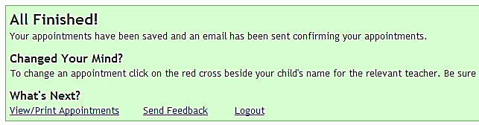 | Step 5: Finished  You will receive an email confirmation of your appointments. You may print this out and bring with you to the parents’ evening. To send the school feedback about this system, click on “Send Feedback”.
Viewing/Editing/Printing Appointments

You can also view and print your appointments online by clicking the “Appointments” tab. You may wish to bring a print out of your appointment times to the parents’ evening if you cannot access them on your smartphone or other device.

You can change your appointments by clicking on “Add/Edit/Delete Appointments”. There is a link at the bottom of the confirmation email which logs you back into the system.

