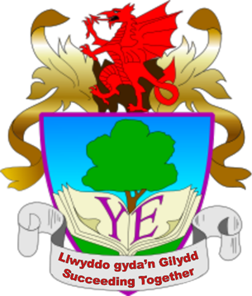
Schedule of Ysgol Eirias Governors Meeting Dates
2021 / 2022

MEETING | 2020/2021  Dates | Term | 2021/2022  Dates
Full Governors | 6.10.20 | Autumn | 28.09.21
Curriculum & Community Committee | 1.12.20 | Autumn | 7.12.21
Personnel Committee | 21.1.21 | Spring | 20.1.22
Finance & Buildings Committee | 16.3.21 | Spring | 22.3.22
Full Governors | 25.3.21 | Spring | 29.3.22
Curriculum & Community Committee | 20.4.21 | Summer | 26.4.22
Personnel Committee | 13.5.21 | Summer | 12.5.22
Finance & Buildings Committee | 22.6.21 | Summer | 21.6.22
Full Governors | 6.7.21 | Summer | 30.6.22

NOTE
- All meetings start at 5pm and will not, normally, last more than two hours (the duration of most Committee meetings is about 1 to 1 ½ hours)
- Committee meetings are held in the Staff Development Room
- Full GB meetings are held in the Reading Room
- Personnel Committee Meetings take place on a Thursday
- Until further notice meetings will be held via TEAMS

Issue 3 - Sept 2021

